OPERATING SYSTEMS ASSIGNMENT 2 – CO2
CO2 Coverage: Analyse process management and deadlock-handling techniques to improve CPU utilisation and system performance – processes, process scheduling, threads, inter-process communication, synchronisation using semaphores, monitors and the critical-section problem, and deadlock handling including the Banker’s algorithm.
Nature of Assignment: Individual
Duration: 1 Week
Total Marks: 50
Submission Date: 06-11-2026
Bloom’s Levels Assessed: K5 – Evaluate (every task in this assignment is at K5 level)
Mandatory Execution and GitHub Submission
- Every student must individually execute every task in this assignment, including all “Complete the Code” programs.
- Create a GitHub repository named CSA04-<RegisterNumber>-Assignment2 and share it with the course faculty (public, or private with the faculty added as a collaborator).
- Keep one folder for each task (for example: Task01, Task02 … or Q1, Q2 …), containing the C source files, shell scripts, configuration files (Dockerfile, YAML), command outputs and screenshots.
- Include a README.md with your name, register number, compiler and version (for example gcc 13), the Linux distribution and version used, the exact gcc command used to compile (for example gcc -std=c11 -Wall -Wextra -pthread), the steps to run each program, and a short note of the result of each task.
- Commit your work progressively – at least one commit for each task. The commit history will be checked; a single upload of all files on the last day will not be accepted.
- Submit the GitHub link below and on the cover page of your report. An assignment submitted without a working GitHub link will not be evaluated.

GitHub Repository Link: https://github.com/192524173simats-karthikreddy/CSA04-192524173
How to Answer the Additional Questions
Complete the Code: Copy the given code into your repository, replace every TODO with working code without changing the rest of the program, execute it and compare your output (or result) with the expected output.
Alternative Concept and Complexity Analysis: Describe how the solution would change if the alternative concept were used, with code or pseudocode, and analyse and compare the time complexity and space complexity of both solutions using Big-O notation, supported by your own measurements wherever possible.

Q1 – Processes and Process States 6 Marks
Bloom’s Level: K5 – Evaluate
Problem Context – Online Examination Server
During an online examination, the server runs a separate process for every student’s session, plus processes for auto-saving answers and for proctoring video. When 2,000 students log in together, the server becomes slow and some sessions appear to “hang”.
Your Challenge
Draw the process-state diagram (new, ready, running, waiting, terminated) and the process control block (PCB). Write a program that creates child processes with fork() and observe them with ps and /proc.
Evaluation
Evaluate where the time goes when 2,000 processes are active: context-switch cost, memory per process, and time spent waiting for I/O. Judge whether a separate process per student is a sound design.
Design Decision
Decide between one process per student, one thread per student and a fixed pool of worker processes, and defend your decision.
Alternative Concept and Complexity Analysis
If each student session were a thread inside one server process, instead of a separate process, what would the solution be? Evaluate the context-switch time and the memory per session (a few KB of stack versus a full address space), and the effect of one session crashing.
Evidence Expected
A state diagram, a PCB description, a working fork() program with ps evidence and a defended design decision.

Q2 – CPU Scheduling 8 Marks
Bloom’s Level: K5 – Evaluate
Problem Context – Cloud Video-Encoding Service
A video service receives short jobs (thumbnails, 2 seconds) and long jobs (full films, 20 minutes) on the same servers. Customers complain that small jobs wait behind large ones, while the company wants the processors fully used.
Your Challenge
Compute the Gantt chart, waiting time, turnaround time and response time for the same set of jobs under FCFS, SJF, SRTF, priority and Round Robin scheduling. Implement Round Robin.
Evaluation
Evaluate how the time quantum affects Round Robin (try 1, 3, 5 and 20), the risk of starvation in SJF and priority scheduling, and how ageing removes it. Explain how a multilevel feedback queue treats short and long jobs.
Design Decision
Recommend the scheduling policy for the video service and justify it with your calculated averages.
Complete the Code
Complete TODO 1 below and execute the program.
#include <stdio.h>

#define N 4

int main(void)
{
const char *name[N] = {"P1", "P2", "P3", "P4"}; int arrival[N] = {0, 1, 2, 3}; int burst[N] = {8, 4, 9, 5}; int quantum = 3;

int left[N], finish[N], queue[64], head = 0, tail = 0, added[N] = {0}; for (int i = 0; i < N; i++) left[i] = burst[i]; int time = 0, done = 0; queue[tail++] = 0; added[0] = 1; printf("Gantt:"); while (done < N) {
int p = queue[head++];
// TODO 1: Run p for min(quantum, left[p]) time units: print " P(time-newtime)",
// advance time, reduce left[p]; add every process that has now arrived and is
// not yet added to the queue; then put p back at the end of the queue if it // still has time left, otherwise record finish[p] and count it as done

}
double tw = 0, tt = 0; printf("\nProcess TAT WT\n"); for (int i = 0; i < N; i++) { int tat = finish[i] - arrival[i], wt = tat - burst[i]; tt += tat; tw += wt; printf("%-7s %4d %3d\n", name[i], tat, wt);
}
printf("Average TAT = %.2f, average WT = %.2f\n", tt / N, tw / N); return 0;
}

Expected output:
Gantt: P1(0-3) P2(3-6) P3(6-9) P4(9-12) P1(12-15) P2(15-16) P3(16-19) P4(19-21) P1(21-23) P3(23-26)
Process TAT WT
P1 23 15
P2 15 11
P3 24 15
P4 18 13
Average TAT = 20.00, average WT = 13.50

Run the program with quantum 1 and quantum 20, and evaluate how the average waiting time and the number of context switches change.
Alternative Concept and Complexity Analysis
If the service used a multilevel feedback queue (short quantum for new jobs, longer quanta for jobs that use them up) instead of a single Round Robin queue, what would the solution be? Evaluate the average waiting time for short and long jobs, the scheduling cost per decision (O(1) per queue versus O(n) for SJF) and the risk of starvation.
Evidence Expected
Correct Gantt charts and averages for every algorithm, a working Round Robin program, a quantum study and a justified recommendation.

Q3 – Threads 6 Marks
Bloom’s Level: K5 – Evaluate
Problem Context – Traffic-Camera Number-Plate Reader
A city traffic system reads number plates from 64 cameras. The first version processes the cameras one after another and falls behind during peak hours.
Your Challenge
Process the camera frames with POSIX threads (one thread per camera, and a pool of 4, 8 and 16 threads). Determine:
- Which resources threads share and which each thread has of its own
- The difference between user-level and kernel-level threads and the many-to-one, one-to-one and many-to-many models
- The speed-up obtained on your machine, and why it stops increasing
- What happens to shared counters when two threads update them without protection

Alternative Concept and Complexity Analysis
If the camera frames were processed by several processes instead of threads, what would the solution be? Evaluate the creation and switching time, the memory used (separate address spaces versus shared), and how the results would be combined (IPC versus shared variables).
Evidence Expected
A working multithreaded program, measured speed-ups for each pool size and a reasoned evaluation of the thread models.

Q4 – Inter-Process Communication 6 Marks
Bloom’s Level: K5 – Evaluate
Problem Context – Weather Station Data Pipeline
A weather station has one process that reads sensors and another that analyses the readings. They must exchange data continuously without losing readings.
Your Challenge
Implement the exchange using a pipe, and then using shared memory or a message queue. Determine:
- How the pipe signals end of data to the reader
- The difference between the shared-memory and message-passing models
- Which method copies the data and which does not
- Which method needs extra synchronisation, and why

Growth Investigation
Measure the time to transfer 1 MB, 10 MB and 100 MB with each method, and evaluate the results.
Complete the Code
Complete TODO 1 below and execute the program on Linux.
#define _POSIX_C_SOURCE 200809L
#include <stdio.h>
#include <unistd.h>
#include <sys/wait.h>

/* The parent (sensor reader) sends readings to the child (analyser) through a pipe. */ int main(void)
{
int fd[2]; if (pipe(fd) == -1) { perror("pipe"); return 1; } pid_t pid = fork(); if (pid == 0) { close(fd[1]); /* child only reads */ int r, count = 0, sum = 0, max = 0;
// TODO 1: Read one int at a time from fd[0] until read returns 0 (the parent // closed the pipe); keep the count, the sum and the maximum

printf("analyser: %d readings, average %.1f, max %d\n", count, count ? (double)sum / count : 0.0, max); close(fd[0]); fflush(stdout);
_exit(0);
}
close(fd[0]); /* parent only writes */ int readings[] = {31, 33, 36, 34, 41, 38}; for (int i = 0; i < 6; i++) if (write(fd[1], &readings[i], sizeof readings[i]) < 0) perror("write"); close(fd[1]); /* signals end of data to the child */ waitpid(pid, NULL, 0); printf("reader: done\n"); return 0;
}

Expected output:
analyser: 6 readings, average 35.5, max 41 reader: done

Remove close(fd[1]) in the parent and explain why the child never finishes.
Alternative Concept and Complexity Analysis
If the readings were exchanged through shared memory with a semaphore instead of a pipe, what would the solution be? Evaluate the time to transfer n readings (two copies through the kernel for a pipe versus none for shared memory) and the synchronisation needed.
Evidence Expected
Two working IPC implementations, measured transfer times and a justified choice of method.

Q5 – Synchronisation: Critical Sections, Semaphores and Monitors 11 Marks
Bloom’s Level: K5 – Evaluate
Problem Context – Railway Ticket Booking
Thousands of agents book seats on the same trains at the same time. Without synchronisation the same seat is sometimes sold twice; with a single global lock the system becomes very slow.
Design Starting Point
You are given only the following principle:
A solution to the critical-section problem must guarantee mutual exclusion, progress and bounded waiting.
Your Challenge
Convert this principle into a design. Determine:
- Why Peterson’s solution satisfies the three requirements for two processes, and why it may fail on modern processors
- How counting and binary semaphores (wait and signal) protect the seat counter
- How the bounded-buffer (producer–consumer), readers–writers and dining-philosophers problems are solved with semaphores
- How a monitor with condition variables makes the solution easier to get right

Test Your Design
Run the bounded-buffer program with 1 and with 4 producers and consumers, and show that every item is consumed exactly once.
Deployment Decision
Decide between one lock for the whole booking system, one lock per train and one lock per coach. Measure the throughput of each and defend your choice.
Complete the Code
Complete TODO 1 and TODO 2 below using the semaphores and the mutex, and execute the program (compile with -pthread).
#define _POSIX_C_SOURCE 200809L
#include <stdio.h>
#include <pthread.h>
#include <semaphore.h>

#define SIZE 5
#define ITEMS 20

int buffer[SIZE], in = 0, out = 0; sem_t empty, full; pthread_mutex_t lock = PTHREAD_MUTEX_INITIALIZER; long consumed_sum = 0;

void *producer(void *arg) {
(void)arg;
for (int item = 1; item <= ITEMS; item++) {
// TODO 1: Wait on empty, lock the mutex, put item at buffer[in], advance in // circularly, unlock, then post full

}
return NULL; }

void *consumer(void *arg) {
(void)arg;
for (int k = 0; k < ITEMS; k++) {
// TODO 2: Wait on full, lock the mutex, take the item at buffer[out], advance // out circularly, unlock, post empty and add the item to consumed_sum

}
return NULL; }

int main(void)
{
sem_init(&empty, 0, SIZE); sem_init(&full, 0, 0); pthread_t p, c; pthread_create(&p, NULL, producer, NULL); pthread_create(&c, NULL, consumer, NULL); pthread_join(p, NULL); pthread_join(c, NULL); printf("items consumed: %d, sum = %ld (expected %d)\n", ITEMS, consumed_sum,
ITEMS * (ITEMS + 1) / 2); sem_destroy(&empty); sem_destroy(&full); return 0;
}

Expected output:
items consumed: 20, sum = 210 (expected 210)

Run the program 100 times and show that the sum is always 210. Then remove the mutex and evaluate whether the result is still correct with several producers and consumers.
Alternative Concept and Complexity Analysis
If the shared counter were protected by atomic operations (C11 atomic_fetch_add) or by a spin lock instead of a semaphore and mutex, what would the solution be? Evaluate the time per update with 1, 4 and 16 threads, the CPU time wasted by spinning, and which method suits a long critical section.
Evidence Expected
A student-derived synchronisation design, working semaphore code, test evidence and a measured, defended locking decision.

DAY-4 DESIGN CHALLENGE

Q6 – Deadlock Handling and the Banker’s Algorithm 13 Marks
Bloom’s Level: K5 – Evaluate
Problem Context – Shared Laboratory Equipment Scheduler
A research centre runs jobs that need several shared resources at once (GPUs, licences for simulation software and high-speed storage). Jobs sometimes wait for each other forever and the whole cluster stops until an administrator intervenes.
A. Characterise Deadlock – 2 Marks
State the four necessary conditions for deadlock and show them in a resource-allocation graph for the cluster.
Complete the Code
Complete TODO 1 below and execute the program.
#include <stdio.h>
#include <string.h>

#define P 5
#define R 3

int avail[R] = {3, 3, 2}; int maxm[P][R] = {{7, 5, 3}, {3, 2, 2}, {9, 0, 2}, {2, 2, 2}, {4, 3, 3}}; int alloc[P][R] = {{0, 1, 0}, {2, 0, 0}, {3, 0, 2}, {2, 1, 1}, {0, 0, 2}};

/* Returns 1 if the state is safe and stores a safe sequence in seq. */ int is_safe(int seq[P])
{
int work[R], finish[P] = {0}, count = 0; memcpy(work, avail, sizeof work); while (count < P) { int found = 0; for (int p = 0; p < P; p++) { if (finish[p]) continue;
// TODO 1: If need = maxm[p] - alloc[p] is <= work for every resource, let p // finish: add alloc[p] to work, mark finish[p], append p to seq and set // found = 1

} if (!found) return 0;
}
return 1; }

void request(int p, const int req[R])
{
for (int r = 0; r < R; r++) if (req[r] > maxm[p][r] - alloc[p][r] || req[r] > avail[r]) { printf("P%d request: must wait (not available)\n", p); return;
}
for (int r = 0; r < R; r++) { avail[r] -= req[r]; alloc[p][r] += req[r]; } int seq[P]; if (is_safe(seq)) {
printf("P%d request: granted, safe sequence", p); for (int i = 0; i < P; i++) printf(" P%d", seq[i]); printf("\n");
} else {
for (int r = 0; r < R; r++) { avail[r] += req[r]; alloc[p][r] -= req[r]; } printf("P%d request: denied (unsafe)\n", p); }
}

int main(void)
{
int seq[P]; if (is_safe(seq)) {
printf("initial state safe:"); for (int i = 0; i < P; i++) printf(" P%d", seq[i]); printf("\n");
}
request(1, (int[R]){1, 0, 2}); request(4, (int[R]){3, 3, 0}); request(0, (int[R]){0, 2, 0}); return 0;
}

Expected output:
initial state safe: P1 P3 P4 P0 P2
P1 request: granted, safe sequence P1 P3 P4 P0 P2
P4 request: must wait (not available) P0 request: denied (unsafe)

Show by hand why the request of P0 for (0, 2, 0) leads to an unsafe state.
Alternative Concept and Complexity Analysis
If deadlock were handled by detection and recovery (running a detection algorithm every few minutes and aborting a job) instead of the Banker’s algorithm, what would the solution be? Evaluate the time per request (O(m × n²) for every Banker’s check versus no check), the cost of detection, and the work lost when a job is aborted.
Evidence Expected
A correct resource-allocation graph identifying all four conditions.
B. Compare the Strategies – 3 Marks
Evaluate prevention (removing one condition), avoidance (Banker’s algorithm), detection and recovery, and ignoring deadlock (the ostrich approach) for the cluster.
Evidence Expected
A reasoned comparison of the four strategies for this environment.
C. Apply the Banker’s Algorithm – 4 Marks
Implement the safety algorithm and the resource-request algorithm. Find a safe sequence for the given state and decide whether each request can be granted.
Evidence Expected
A working implementation with correct safe sequences and decisions.
D. Predict Before Implementing – 1 Mark
Predict how the running time of the Banker’s algorithm grows with the number of processes n and resource types m.
Evidence Expected
A clear, testable prediction.
- Measure – 1 Mark
Measure the time of the safety algorithm for 10, 100 and 1,000 processes and compare it with your prediction.
Evidence Expected
Measured times compared with the prediction.
- Defend the Final Design – 2 Marks
Recommend the deadlock strategy for the research centre and justify it, including the cost of the Banker’s algorithm and the need to know maximum demands in advance.
Evidence Expected
A critical, evidence-based recommendation.

MARK DISTRIBUTION
Question | Assessed Area | Bloom’s Level | Marks
Q1 | Processes and process states | K5 – Evaluate | 6
Q2 | CPU scheduling | K5 – Evaluate | 8
Q3 | Threads | K5 – Evaluate | 6
Question | Assessed Area | Bloom’s Level | Marks
Q4 | Inter-process communication | K5 – Evaluate | 6
Q5 | Synchronisation: critical sections, semaphores and monitors | K5 – Evaluate | 11
Q6 | Day-4 Design Challenge – Deadlock handling and Banker’s algorithm | K5 – Evaluate | 13
 | TOTAL |  | 50

Submission Requirements
GitHub repository link (mandatory) containing the executed code for every task, including every completed “Complete the Code” program, script and configuration file, with input files, output screenshots and a README.md.
- Your assignment report containing the required evidence for Q1–Q6
- C source code for all programs
- Gantt charts, diagrams, outputs and timings used as evidence

Assessment Verification
Students may be asked to explain any part of their design, code, calculations or results during a brief verification discussion/viva.
Overall Assessment Expectation
Model → Design → Implement → Measure → Compare → Evaluate → Recommend

1. Introduction, Objectives and Requirements
This report presents the design of a battery-less smart water meter capable of continuously monitoring water consumption and periodically reporting the measured data without relying on a replaceable battery or a permanent mains supply. The meter derives its energy from an ambient energy-harvesting source and stores it in a capacitor or an equivalent storage element. Because the available energy is limited and intermittent, the design treats energy as a constrained resource and coordinates sensing, processing, storage and wireless communication around short, well-defined active periods.
The central engineering objective is an ultra-low-power, microcontroller-based architecture that wakes periodically, acquires flow and housekeeping measurements, validates the readings, accumulates consumption data, stores critical information in non-volatile memory and transmits it over a low-power wireless interface. Supply monitoring and brown-out handling are built in so that a temporary energy shortfall never corrupts accumulated data.

1.1 Design Objectives
- Use ambient energy harvesting as the primary energy source and store harvested energy for burst operation.
- Use a timer/RTC and interrupts to implement periodic wake-up instead of continuous polling.
- Measure flow, temperature, tamper status and supply voltage while minimizing active time.
- Use the ADC, GPIO, timers/RTC, non-volatile memory and wireless peripherals efficiently.
- Protect data during low-voltage, brown-out and unexpected-reset conditions.
- Evaluate energy, timing, memory, sensing, communication and reliability performance.

1.2 Functional Requirements
Parameter | Required Design
Energy source | Ambient energy-harvesting source
Energy storage | Capacitor or suitable energy-storage element
Sensors | Flow, temperature, tamper and supply-voltage monitoring
Processor | Ultra-low-power microcontroller
Operating mode | Sleep / wake cycles
Sampling | Periodic acquisition
Control | Timer/RTC and interrupt based
Storage | Non-volatile memory
Communication | Low-power wireless
Recovery | Data protection and reset recovery

1.3 Sustainability and Reliability
Battery-less operation removes the need for replaceable batteries, supporting the assignment's sustainability mapping to SDG 9 (Industry, Innovation and Infrastructure), SDG 11 (Sustainable Cities and Communities) and SDG 12 (Responsible Consumption and Production). Reliability is achieved through energy-aware scheduling, brown-out detection, protected non-volatile storage and recovery of the last valid system state after any interruption.

2. System Architecture and Component Selection
The proposed architecture separates the system into energy-harvesting, energy-storage, sensing, computation, memory, communication and protection functions. A suitable implementation uses an ultra-low-power microcontroller with an integrated ADC, RTC/timers, GPIO, interrupt controller, non-volatile-memory support and deep-sleep modes. The exact device may be selected according to the final simulation or hardware platform; the assignment requires the selection to be justified rather than prescribing one specific controller.
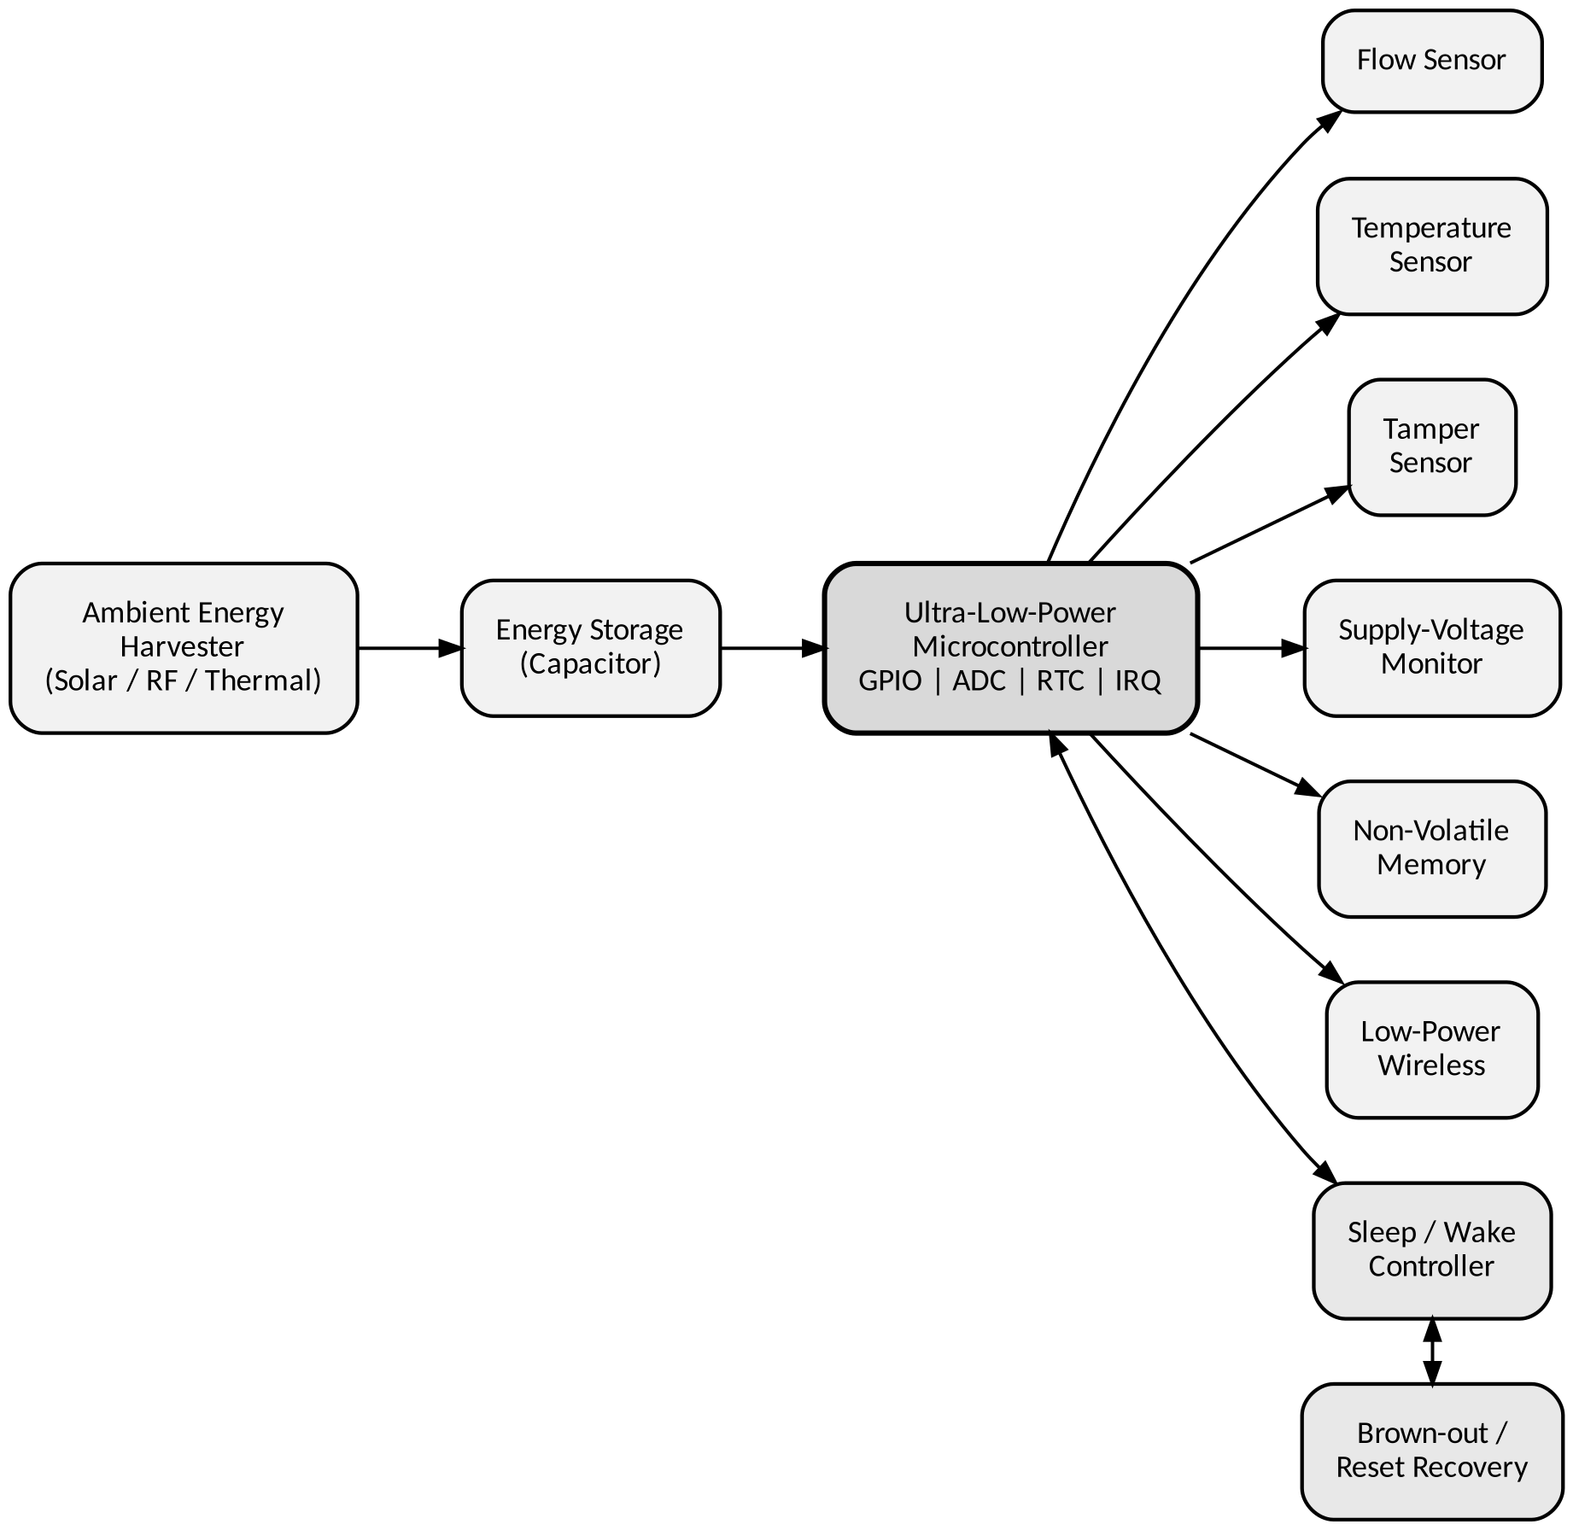
Figure 1. Proposed battery-less smart water meter architecture

2.1 Major Modules
Module | Function | Design Consideration
Energy harvester | Converts ambient energy into usable electrical energy | Operate reliably under variable harvested power
Storage element | Stores energy between harvesting and active cycles | Capacitor/energy store sized for burst load
Flow sensor | Provides water-flow information | Low-power acquisition and pulse/ADC interface
Temperature sensor | Measures relevant temperature information | Enable only when needed
Tamper sensor | Detects tamper status | Interrupt-capable GPIO preferred
Voltage monitor | Measures available supply | ADC / comparator / brown-out support
Microcontroller | Coordinates all operations | Low active current and deep-sleep capability
NVM | Stores accumulated and recovery data | Write only necessary records to reduce energy/wear
Wireless | Reports required information | Short communication window and low energy

2.2 Microcontroller Selection Rationale
A low-power microcontroller with multiple sleep states, fast wake-up, timer/RTC operation during sleep, configurable GPIO interrupts, ADC channels, brown-out/reset circuitry and non-volatile storage support is appropriate for this application. These features allow the controller to remain asleep for most of the reporting interval while retaining enough functionality to wake autonomously and complete the measurement cycle quickly.

3. Sensor Interfacing, Firmware and Control Strategy
The firmware follows an interrupt-driven architecture. A timer or RTC generates the periodic wake event, after which the controller enables only the peripherals required for the current measurement cycle. Sensor data is acquired through GPIO, pulse counting and/or ADC channels, processed, validated, accumulated and written to non-volatile memory. Wireless transmission is performed only when the reporting schedule or stored-data policy requires it; unnecessary peripheral clocks are then disabled and the controller returns to a low-power state.

3.1 GPIO and ADC Configuration
- Flow input — configured as a digital input or pulse-counting interrupt input depending on the selected flow sensor.
- Temperature input — connected to an ADC channel or a digital sensor interface, as appropriate.
- Tamper input — configured as an interrupt-capable GPIO so that an event can wake the controller.
- Supply-voltage monitor — sampled through an ADC channel or a comparator/brown-out circuit.
- Wireless interface — configured only during the communication phase; peripheral clocks remain disabled during sleep.

3.2 Flow Measurement and Validation
For a pulse-output flow sensor, the controller counts valid pulses during a defined measurement window. If K is the calibrated pulse constant (pulses per unit volume) and N is the number of valid pulses, the estimated volume is:
Volume = N / K
For a flow rate measured over a sampling interval Δt, the rate is estimated by dividing the measured volume by Δt. The firmware rejects impossible values, detects missing or excessive pulses, and preserves the last valid accumulated value whenever a supply fault occurs.

3.3 Timer/RTC and Interrupt Strategy
Event | Interrupt / Action | Purpose
RTC/timer tick | Wake MCU | Periodic acquisition
Flow pulse | Increment/record count | Accurate flow measurement
Tamper event | Wake and flag event | Immediate status capture
ADC completion | Process sample | Reduce waiting/polling
Wireless completion | Store status and sleep | End communication window
Brown-out / reset | Protect state | Prevent data corruption

3.4 Firmware Control Flow
The consolidated control flow below implements the initialization, sensing, validation, storage and reporting sequence described above, including the low-voltage protection branch that safeguards accumulated data.
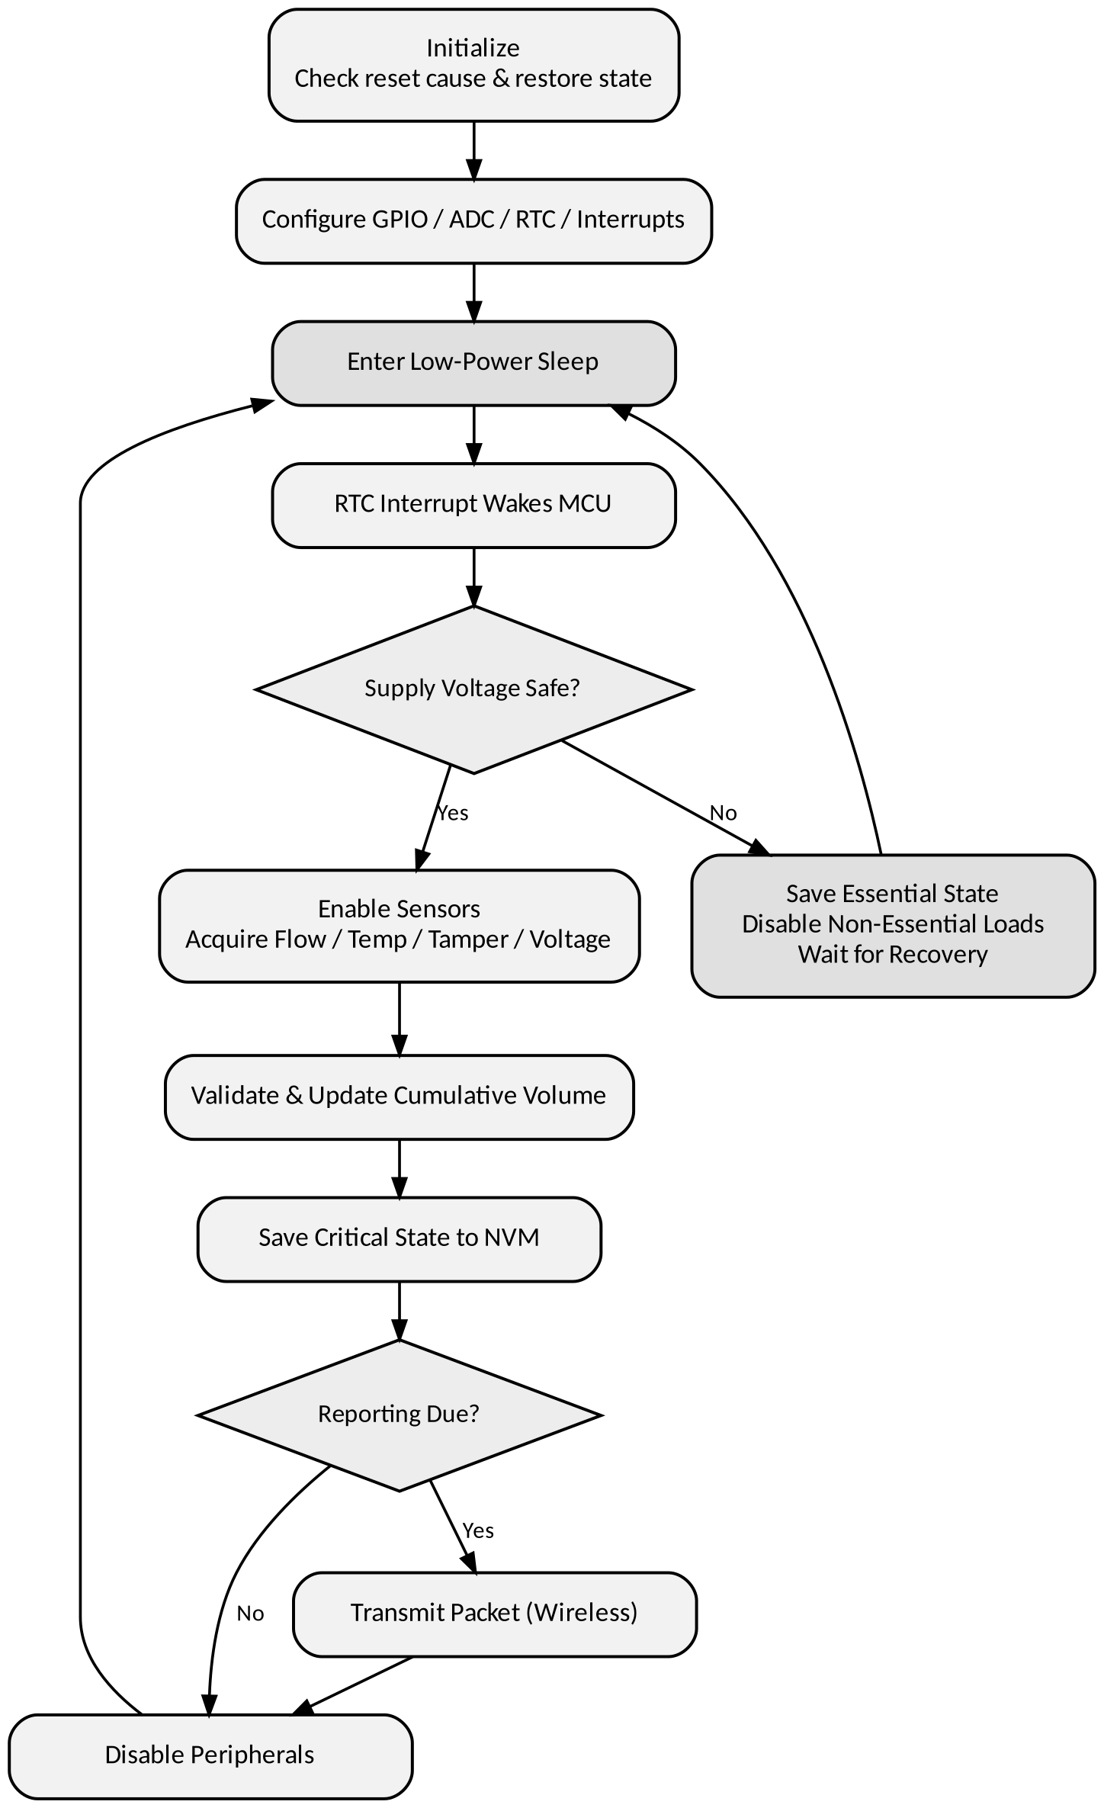
Figure 2. Firmware wake–sense–store–report control flow

4. Low-Power Operation, Memory and Recovery
Because harvested energy varies with environmental conditions, the meter must spend the largest possible fraction of time in a low-power state. Peripheral clock management is important, since unused clocks consume energy even when the CPU is idle. The sensing and communication phases are therefore treated as short energy bursts separated by long sleep periods.

4.1 Non-Volatile Memory Organization
Record | Stored Information | Reason
Meter total | Cumulative valid water consumption | Maintains long-term reading
Last valid sample | Most recent validated measurement | Supports reset recovery
Sequence/counter | Record sequence number | Detects incomplete writes
Configuration | Calibration/reporting parameters | Restores operating settings
Fault/status | Brown-out/tamper/reset flags | Supports diagnostics
A simple wear-aware record scheme maintains two or more slots, each containing a sequence number, a data payload and a validity marker. A new record is written to an unused slot and is treated as valid only once the write completes. After a reset, the firmware selects the newest valid record, which prevents an interrupted write from overwriting the previous valid state.

4.2 Brown-Out and Unexpected-Reset Recovery
When the supply falls below the safe operating threshold, the system avoids starting a new sensing or wireless cycle. The brown-out mechanism or voltage monitor identifies the condition and, if enough energy remains, the firmware stores the latest validated state and fault information. After recovery, the reset-cause register and validity markers are checked before normal operation resumes — protecting accumulated water-consumption data and preventing invalid partial records from being accepted.

4.3 Wireless Communication Strategy
The wireless interface remains off except during the reporting window. A compact packet carries device/status information, cumulative volume, the most recent flow value, temperature, tamper flag and supply condition. If communication fails, the meter retains the data locally and retries later rather than repeatedly consuming energy in an extended connection attempt.

5. Energy, Timing and Performance Analysis
Since the assignment requires quantitative evaluation, the following design calculations provide a representative analysis framework; actual values should be replaced by measured simulation or hardware results once implementation evidence is available.

5.1 Energy-Budget Calculation
For each operating phase, energy is approximated by E = V × I × t. A complete cycle is the sum of the sleep, sensing, processing, memory and communication energy. The illustration below assumes a 3.0 V supply and the representative operating values shown.
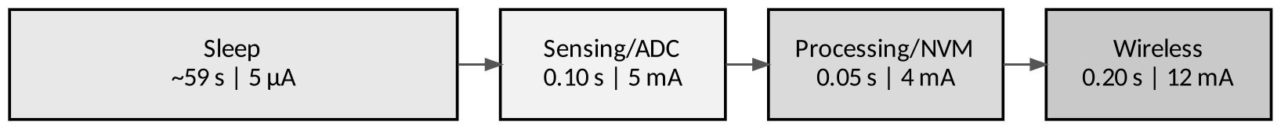
Figure 3. Representative 60-second operating cycle by phase
Phase | Current | Time | Energy
Sleep | 5 µA | 59 s | 0.885 mJ
Sensing/ADC | 5 mA | 0.10 s | 1.500 mJ
Processing/NVM | 4 mA | 0.05 s | 0.600 mJ
Wireless | 12 mA | 0.20 s | 7.200 mJ
Total per 60 s cycle | — | 60 s | 10.185 mJ
The example total is 10.185 mJ per minute, equivalent to approximately 0.170 mW average power. This demonstrates why communication should be kept short and why deep sleep is essential; the actual energy budget must be determined from the selected hardware and measured current profiles.

5.2 Performance Parameters
Parameter | Target / Analysis Method | Expected Design Behaviour
Energy/cycle | Sum V·I·t for all phases | Minimize active and radio time
Average power | Cycle energy ÷ cycle period | Must remain below harvested-energy average
Flow accuracy | Compare measured and reference volume | Calibration and validation reduce error
Reporting interval | RTC schedule | Stable periodic reporting
Execution time | Timestamp wake-to-sleep | Keep active window short
Sleep current | Current in deepest useful mode | Very low relative to active current
Memory utilization | Used records ÷ available NVM | Keep compact and wear-aware
Communication reliability | Successful packets ÷ attempts | Retry without wasting energy
Brown-out recovery | Time from safe voltage to normal state | Restore last valid state

5.3 Energy Margin and Design Trade-Off
A positive energy margin exists when the energy harvested and stored over the operating period exceeds the energy required by the complete sensing–processing–communication cycle. Increasing the reporting frequency improves data freshness but increases communication energy; reducing sensor sampling lowers energy consumption but may reduce measurement resolution. The design therefore prioritizes local accumulation, short sensing windows, compact packets and long sleep intervals.

6. Testing, Validation, Limitations, Reflection and Conclusion

6.1 Test Cases
Test Condition | Expected Response | Acceptance Evidence | Conclusion
Normal harvested energy | Wake, sense, store and report normally | Cycle completes without data loss | Pass when all functions complete
Reduced harvested energy | Increase sleep time / avoid unnecessary transmission | System remains stable and preserves data | Pass if data remains valid
Low supply / brown-out | Stop non-essential activity and protect state | Fault/reset cause recorded | Pass if previous valid state survives
Communication interruption | Retain data and retry later | No loss of cumulative reading | Pass if local data is preserved
Unexpected reset | Restore newest valid record | Meter resumes from valid state | Pass if no partial record is accepted
Tamper event | Capture event and status | Tamper flag stored/reported | Pass if event is detected

6.2 Limitations
- The exact microcontroller and sensor part numbers are not fixed by the assignment, so final electrical characteristics depend on the chosen implementation platform.
- Ambient energy availability can change with environmental conditions; the energy budget must therefore be validated under worst-case harvesting conditions.
- Wireless range and reliability depend on the selected low-power protocol and installation environment.
- Flow-meter accuracy ultimately depends on sensor calibration, installation and water-flow characteristics.
- The numerical energy values in this report are representative design calculations, not measured laboratory results.

6.3 Reflection
This design exercise connected microcontroller architecture with practical energy-aware embedded-system design. The most important decision was to treat the energy harvester and storage element as a constrained power budget rather than an unlimited supply — directly shaping a firmware strategy in which the controller sleeps for most of the operating cycle and wakes only when an RTC/timer interrupt or an important event requires action. GPIO interrupts, ADC usage, peripheral clock control and non-volatile memory therefore form a single coordinated design rather than independent features.
A second key decision was to separate measurement from reporting: water-flow information is accumulated locally, while wireless communication occurs at a less frequent interval. This reduces repeated radio activation and improves compatibility with intermittent harvested energy, trading data freshness for lower energy consumption. The brown-out and recovery requirement further highlighted the importance of data integrity — validity markers and sequence information in non-volatile memory reliably distinguish the latest complete record from an interrupted write. Future improvements could include adaptive reporting based on stored energy, more advanced flow-sensor calibration, energy-aware communication retries and measured hardware validation.

6.4 Conclusion
The proposed architecture satisfies the assignment requirements by integrating ambient energy harvesting, energy storage, an ultra-low-power microcontroller, flow and housekeeping sensors, ADC/GPIO interfaces, timer/RTC scheduling, interrupt-driven firmware, non-volatile storage, low-power wireless communication and brown-out/recovery mechanisms. The sensing–processing–storage–communication–sleep cycle is designed to complete within the available energy budget. Quantitative energy and performance analysis provides a basis for validating the design, while the test plan addresses normal operation, reduced energy, communication interruption, brown-out and unexpected reset. Overall, the battery-less approach supports autonomous and sustainable water monitoring while emphasizing low energy consumption, measurement reliability and data integrity.

References / Design Basis
- Assignment brief: ECA1005 – Microprocessors and Microcontrollers, "Design of an Ultra-Low-Power Battery-Less Smart Water Meter Using a Microcontroller."
- Microcontroller datasheet and reference manual for the final selected device (to be added for the implemented platform).
- Flow-sensor datasheet and calibration information for the selected sensor (to be added for the implemented platform).
- Wireless-module datasheet and protocol documentation for the final selected communication interface (to be added for the implemented platform).

